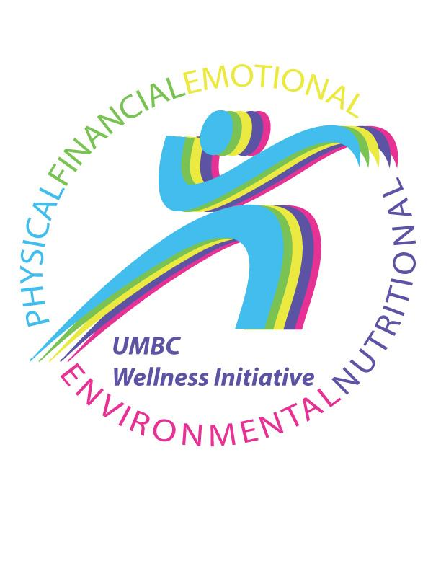
2018 – 2019 Wellness Ambassadors

Carol Bateman | choppy@umbc.edu | DPS
Steve Bowers | bowers@umbc.edu | Financial Services
Shirley Carrington | shirleyc@umbc.edu | Shriver Center
Doha Chibani | chibani1@umbc.edu | Counseling Center
Lorine Dabeck | dabeck@umbc.edu | Learning Resources Center
David Freeman | dave@umbc.edu | DoIT
Jane Henderson | jhenders@umbc.edu | CNMS Dean's Office
Sarah Hansen | hansen.sarah@umbc.edu | Institutional Advancement
Gergana Kostova | g.kostova@umbc.edu | Library
Alexandra Kuczka | alikuczka@umbc.edu | Registrar’s Office
Lisa Manley | lmanley@hilltop.umbc.edu | The Hilltop Institute
Michelle Massey | massey@umbc.edu | International Education Services
Wanda Nottingham | wsoares@umbc.edu | Africana Studies
Javier Rivera Guzman | jriverag@umbc.edu | Biology
Julie Rosenthal | julier@umbc.edu | Asian Studies
Marsha Velli | mvelli@umbc.edu | Imaging Research Center

